Ideation Phase
Brainstorm & Idea Prioritization Template

Date | 15 July 2026
Team ID
Project Name | Cosmetics Insights
Maximum Marks | 4 Marks

Brainstorm & Idea Prioritization Template:
Brainstorming helped our team generate different ideas to solve the identified problem. We discussed the challenges faced in analyzing cosmetics sales data and explored multiple solutions. After evaluating each idea based on its feasibility, usefulness, and impact, we selected the most suitable approach. This process helped us finalize the development of an interactive Cosmetics Insights Dashboard using Tableau to provide meaningful visualizations and support better business decisions.
Step-1: Team Gathering, Collaboration and Select the Problem Statement
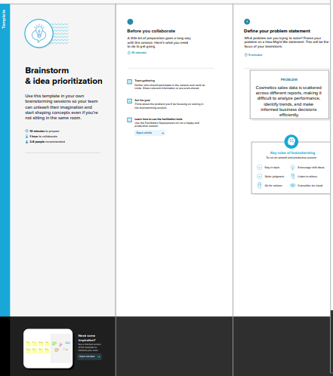

Step-2: Brainstorm, Idea Listing and Grouping
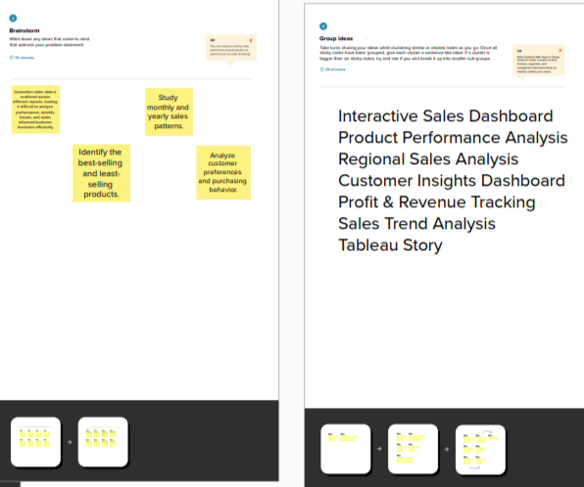

Step-3: Idea Prioritization
